Network Rules
Overall
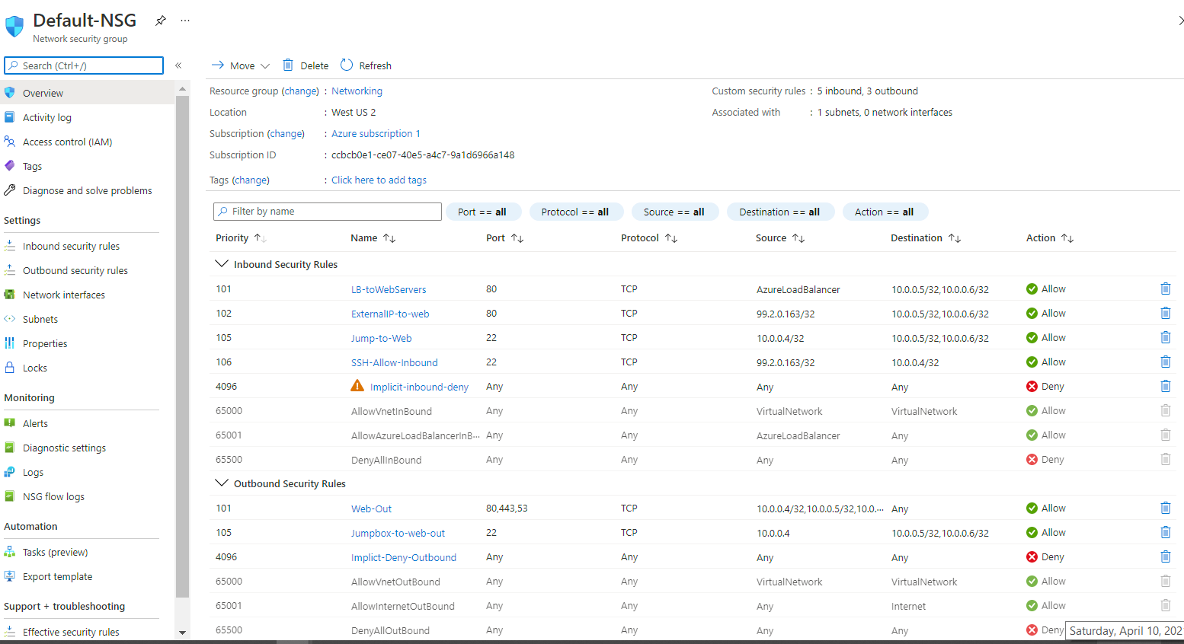

INBOUND
- Load Balancer to Web Servers
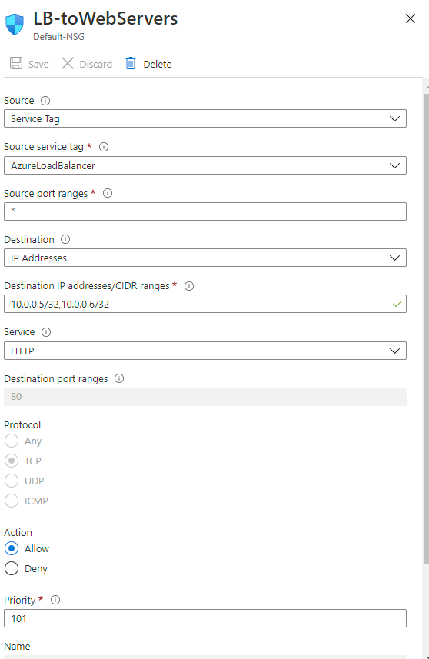
- Your Home External IP to the Web Servers
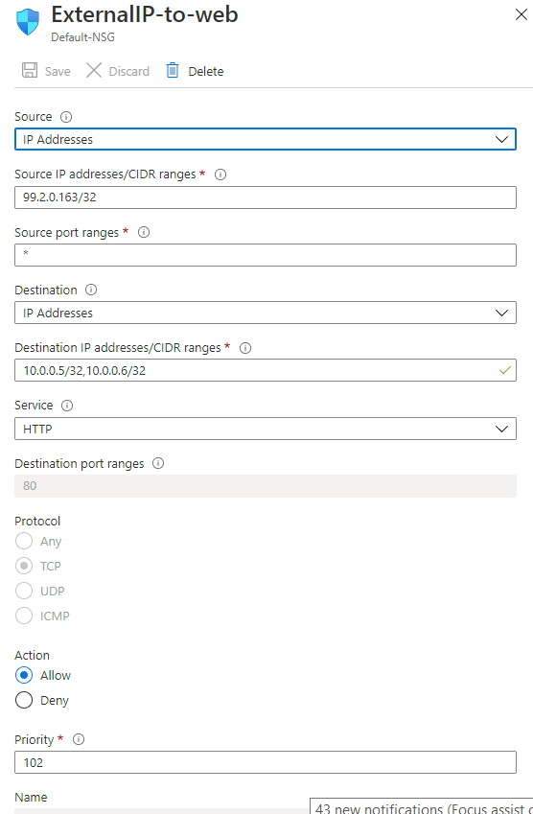
- Jumpbox can SSH to Web Servers
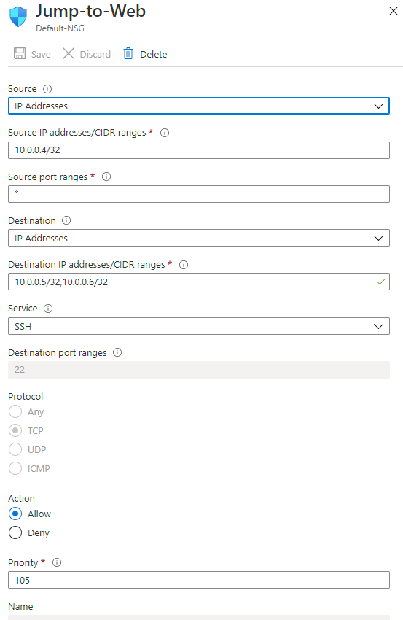

- SSH from our Home External IP to the JumpBox
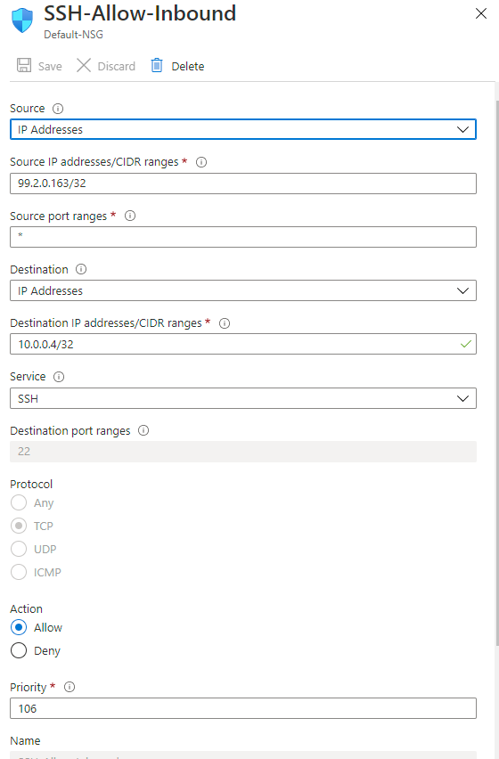

OUTBOUND
- Allow all servers to communicate out to the web over http,https,dns
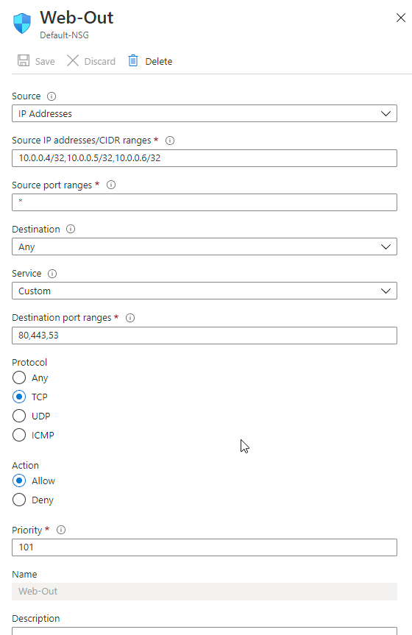
- Jumpbox to SSH to Web Servers
